A

Technical Report

on

**OBSTACLE DETECTION**

*Submitted to CMR Institute of Technology in the partial fulfillment of the requirement of*

**Social Innovation Lab**

Of

**II B.Tech I- Semester**

in

**ECE DEPARTMENT**

Submitted by

**K. Kavya Reddy** **(20R01A04L3)**

**D. Srija** **(20R01A04K6)**

**G. Vaishnavi** **(20R01A04K8)**

**G. Naresh Kumar** **(20R01A04L0)**

**G. Vinay** **(20R01A04K9)**

**K. Mahidhar** **(20R01A04L4)**

***Under the esteemed guidance of***

***MS.K. NEELIMA***

***ASSISTANT PROFESSOR***



**CMR INSTITUTE OF TECHNOLOGY**

**(UGC-AUTONOMOUS)**

(Approved by AICTE, Permanently Affiliated to JNTU Hyderabad, accredited by NBA, Accredited by NAAC with A Grade)

Kandlakoya (V), Medchal Road, Hyderabad  501 401

**2020-2021**

***Department of ECE***

**Certificate**

This is to certify that the technical report entitled "OBSTACLE DETECTION” is the Bonafide work done and submitted by

**K. Kavya Reddy** **(20R01A04L3)**

**D. Srija** **(20R01A04K6)**

**G. Vaishnavi** **(20R01A04K8)**

**G. Naresh Kumar** **(20R01A04L0)**

**G. Vinay**  **(20R01A04K9)**

**K. Mahidhar** **(20R01A04L4)**

towards the partial fulfillment of the requirement of Social Innovation (SIL) Laboratory of **II B. Tech I-Semester** in **ECE** is a record of Bonafide work carried out by them during the period Sep 2020 **to Jan 2021.**

**Guide**   **Co- Ordinator**   **Head of Department**

***Ms. K. Neelima Mr.C.Ramakrishna***  ***Dr. Niranjan Reddy***

**INDEX**

**Topics** **Page No**

**CHAPTER-I** **INTRODUCTION** **4**

**CHAPTER II**  **Empathize**  **6**

**CHAPTER III** **Define** **7**

**CHAPTER IV** **Ideate** **8**

**CHAPTER V**  **Prototype** **9**

**CHAPTER VI**  **Test** **18**

**REFERENCES** **18**

**INTRODUCTION**

* **WHAT IS SOCIAL INNOVATION?**

The term ‘social innovation ’once rarely heard is, now often used to describe a whole variety of things that fall into general categories of being both new and good. It's understandable that the phrase has become popular-we get excited and hopeful when it seems possible for real change to happen in the world.

Social innovation refers to the Design and implementation of new solutions that imply conceptual, process, product or organizational change which ultimately aim to improve the welfare and wellbeing of individual communities

Social innovation is not a new concept and should not be considered similar to other definitions, such as social entrepreneurship, creativity or invention, improvement or change. 'As with innovation in technology or business, social innovation is distinct from ‘improvement’ or ‘change’ and from ‘creativity’ and ‘invention’. These last two are both crucial to innovation but overlook the important stages of implementation and diffusion which make new ideas useful.

* **What is design thinking process?**

Design Thinking is a design methodology that provides a solution-based approach to solving problems. It’s extremely useful in tackling complex problems that are ill-defined or unknown, by understanding the human needs involved, by re-framing the problem in human-centric ways, by creating many ideas in brainstorming sessions, and by adopting a hands-on approach in prototyping and testing. Understanding these five stages of Design Thinking will empower anyone to apply the Design Thinking methods in order to solve complex problems that occur around us — in our companies, in our countries, and even on the scale of our planet.

Design thinking originally came about as a way of teaching engineers how to approach problems creatively, like designers do. One of the first people to write about design thinking was John E. Arnold, professor of mechanical engineering at Stanford University.

**The Five Stages of Design thinking Process:**

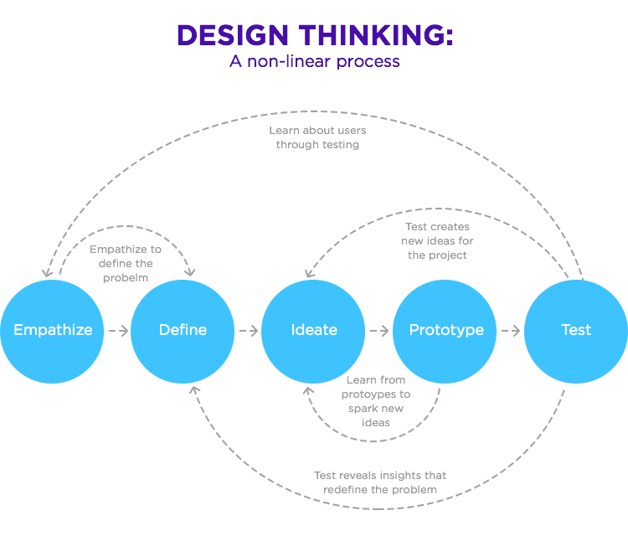

* Empathize: Empathy is considered the **starting point for any design project**, and constitutes phase one of the Design Thinking process. During the empathize phase, the designer spends time getting to know the user and understanding their needs, wants, and objectives.
* Define: The Define stage will help the designers in your team gather great ideas to establish features, functions, and any other elements that will allow them to solve the problems or, at the very least, allow users to resolve issues themselves with the minimum of difficulty.
* Ideate: In this section, called Ideate, a design thinker is supposed to bring to the table as many ideas as possible. While brainstorming for ideas, it is not checked whether the idea is possible, feasible, and viable or not. The only task of thinkers is to think of as many ideas as possible for them.
* Prototype: Prototypes are often used in the **final, testing phase** in a Design Thinking process in order to determine how users behave with the prototype, to reveal new solutions to problems, or to find out whether or not the implemented solutions have been successful.
* Test: Testing, in Design Thinking, involves generating user feedback as related to the prototypes you have developed, as well as gaining a deeper understanding of your users.

**1.EMPATHIZE**

The first stage of the Design Thinking process is to gain an empathic understanding of the problem you are trying to solve. This involves consulting experts to find out more about the area of concern through observing, engaging and empathizing with people to understand their experiences and motivations, as well as immersing yourself in the physical environment so you can gain a deeper personal understanding of the issues involved.

Empathy requires active listening and rapport-building for a deep understanding that can transcend innate personal bias or pre conceived notions.

Our team has conducted a survey among people at current problems faced by them in day-to-day life. In those problems listed, we found many valid problems, and we have short listed few problems which are being affected by most of the people.

The major problems we perceive is Accidents in that accidents the major cause for accident is mostly at early morning and overnight.

**2.DEFINE**

In this define stage, we have defined the problem statement accordingly to our problem. According to the scenario as we have collected information in the empathy stage, we have defined the problem statement as DETECTION”.

**Problem statement:**

Protecting ourself from obstacles during night or in foggy and in pollution in front of cars and all other vehicles, since they cause reduced visibility, the chances of occurring an accidents is much higher and it also help us in saving animals which are getting hit by vehicles during night.

OBJECTIVE:

* The main motive of our project is to reduce the likelihood of much higher occurrence of accident, majority due to fog and pollution.
* To prevent accidents and saving animals from killing by hitting vehicles during night and foggy days since they cause reduced visibility.

**Advantages:**

* **Create Awareness**
* The main perk that you can get from using a radar detector is for creating awareness.
* The function is to warm or alert when there is obstacle ahead of your vehicle.
* They Improve safety radar increases your safety when obstacle is Infront of the vehicle it defects priority and gives information.

**3.IDEATE**

In this section, called Ideate, a design thinker is supposed to bring to the table as many ideas as possible. While brainstorming for ideas, it is not checked whether the idea is possible, feasible, and viable or not. The only task of thinkers is to think of as many ideas as possible for them.

Protecting ourselves from obstacles during night or in foggy days in front of car to save us from accidents and it also helps us in saving animals which are getting hit by vehicles during night and it reduces accidents.

The Radar System using Arduino. In this work, the distance of the object is measured through an ultrasonic distance sensor, and the sensor output is connected to the signal conditioning unit. After that, it is processed through the Arduino microcontroller. The measured results are displayed on the personal computer. The sensor is attached to servo motor to find the polar distance around the sensor up to 180 rotations.

A radar system has a transmitter that emits radio waves called a radar signals in predetermined directions. When these come into contact with an object they are usually reflected or scattered in many directions

Example: - let us take example for bat

Bat released the eco sound while travelling. if any object came in middle and it reflect back to the bat

The development of the radar technology took place during the World War II in which it was used for detecting the approaching aircraft and then later for many other purposes which finally led to the development of advanced military radars being used these days. Military radars have a highly specialized design to be highly mobile and easily transportable, by air as well as ground. Military radar should be an early warning, altering along with weapon control functions. It is specially designed to be highly mobile and should be such that it can be deployed within minutes.

**4. PROTOTYPE**

The next step is making a prototype, that is for making a prototype we require components like

**COMPONENTS REQUIRED: -**

**1) Arduino**

**2) Servo Motor**

**3) Ultra sonic sensor**

**4) Processing Software**

**Total cost of our project is: 900/-**

**1) Arduino:**

**Product Description:** Arduino is an open-source computer hardware and software company, project, and user community that designs and manufactures single-board microcontrollers and microcontroller kits for building digital devices and interactive objects that can sense and control objects in the physical world. The boards are equipped with sets of digital and analog input/output (I/O) pins that may be interfaced to various expansion boards (shields) and other circuits. The boards feature serial communications interfaces, including Universal Serial Bus (USB) on some models.

The microcontrollers are typically programmed using a dialect of features from the programming languages C and C++.

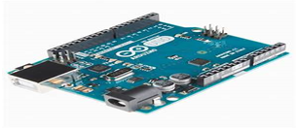 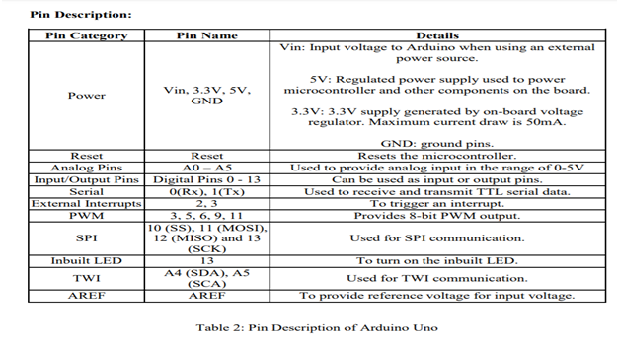

**2) Servo Motor:**  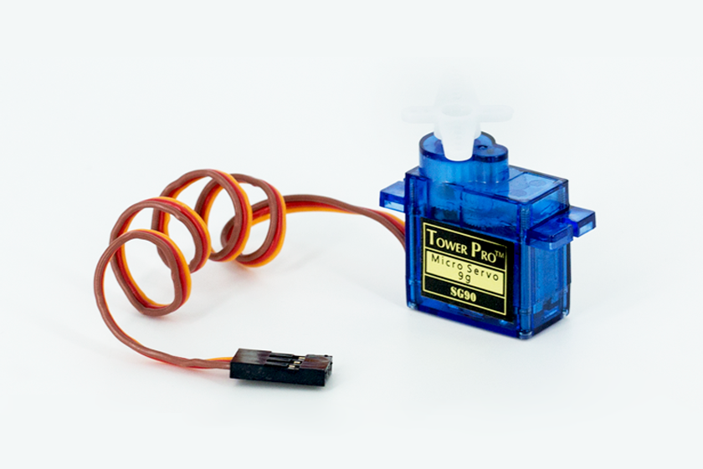

Tiny and lightweight with high output power. The servo will rotate about 180 degrees (90 in each direction) and operate just as small as the regular types. To monitor these services, you can use any servo code, hardware or library.

The Specifications of servo motor

• Weight: 9 g

• Dimension: 22.2 x 11.8 x 31 mm approx.

• Stall torque: 1.8 kg f cm

• Operating speed: 0.1 s/60 degree

• Operating voltage: 4.8 V (~5V)

• Temperature range: 0 ºC – 55 ºC

**3) Ultra sonic sensor:**

As the name indicates, ultrasonic sensors measure distance by using ultrasonic waves. The sensor head emits an ultrasonic wave and receives the wave reflected back from the target. Ultrasonic Sensors measure the distance to the target by measuring the time between the emission and reception. An optical sensor has a transmitter and receiver, whereas an ultrasonic sensor uses a single ultrasonic element for both emission and reception. In a reflective model ultrasonic sensor, a single oscillator emits and receives ultrasonic waves alternately. This enables miniaturization of the sensor head. Distance calculation

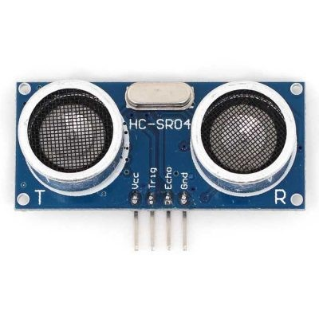

The distance can be calculated with the following formula:

Distance L = 1/2 × T × C

**4) Processing Software:**

All processing is an open-source computer programming language and integrated development environment (IDE) built for the electronic arts, new media art, and visual design communities to teach the fundamentals of computer programming in a visual context. The Specifications of programming:

• Free to download and open source

• Interactive programs with 2D, 3D or PDF output

• OpenGL integration for accelerated 2D and 3D

• For GNU/Linux, Mac OS X, and Windows

• Over 100 libraries extend the core software

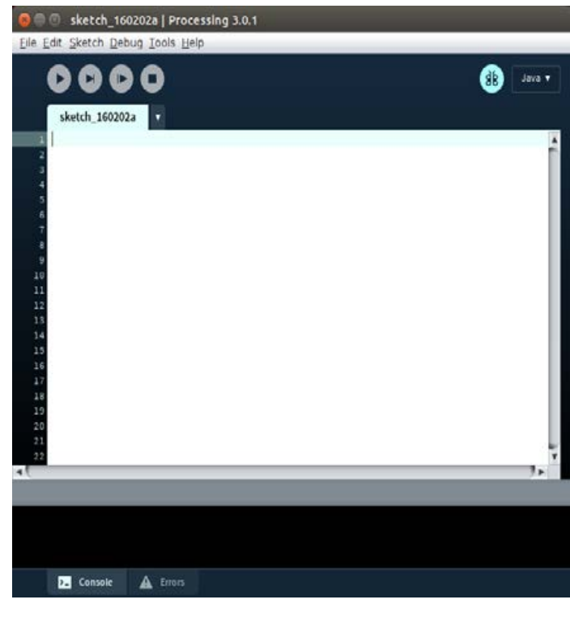

**SOURCE CODE:-**  
#include .<Servo.h>

int trigPin = 10;

const int echoPin = 11;long duration;

int distance;

Servo myServo; void setup() {

pinMode(trigPin, OUTPUT);

pinMode(echoPin, INPUT);

Serial.begin(9600);

myServo.attach(12);

}

void loop() {

for(int i=15;i<=165;i++){

myServo.write(i);

delay(30);

distance = calculateDistance();

Serial.print(i);

Serial.print(",");

Serial.print(distance);

Serial.print(".");

}

for(int i=165;i>15;i--){

myServo.write(i);

delay(30);

xx distance = calculateDistance();

Serial.print(i);

Serial.print(",");

Serial.print(distance);

Serial.print(".");

}

}

int calculateDistance(){

digitalWrite(trigPin, LOW);

delayMicroseconds(2);

seconds digitalWrite(trigPin, HIGH);

delayMicroseconds(10);

digitalWrite(trigPin, LOW);

duration = pulseIn(echoPin, HIGH); // Reads the echoPin, returns the sound wave travel time in microseconds distance= duration*0.034/2;

return distance;

}

**PROCESSOR CODE:**

import processing.serial.*;

import java.awt.event.KeyEvent;

import java.io.IOException;

Serial myPort;

String angle="";

String distance="";

String data="";

String noObject;

float pixsDistance;

int iAngle, iDistance;

int index1=0;

int index2=0;

PFont orcFont;

**void** **setup**() {

size (1200, 700);

smooth();

myPort = **new** Serial(this,"COM5", 9600);

myPort.bufferUntil('.');.

}

**void** **draw**() {

fill(98,245,31);

noStroke();

fill(0,4);

rect(0, 0, width, height-height*0.065);

fill(98,245,31);

**drawRadar**();

**drawLine**();

**drawObject**();

**drawText**();

}

**void** **serialEvent** (Serial myPort) {

data = myPort.readStringUntil('.');

data = data.substring(0,data.length()-1);

index1 = data.indexOf(",");

angle= data.substring(0, index1);

distance= data.substring(index1+1, data.length());

iAngle = int(angle);

iDistance = int(distance);

}

**void** **drawRadar**() {

pushMatrix();

translate(width/2,height-height*0.074);

noFill();

strokeWeight(2);

stroke(98,245,31);

arc(0,0,(width-width*0.0625),(width-width*0.0625),PI,TWO_PI);

arc(0,0,(width-width*0.27),(width-width*0.27),PI,TWO_PI);

arc(0,0,(width-width*0.479),(width-width*0.479),PI,TWO_PI);

arc(0,0,(width-width*0.687),(width-width*0.687),PI,TWO_PI);

line(-width/2,0,width/2,0);

line(0,0,(-width/2)*cos(radians(30)),(-width/2)*sin(radians(30)));

line(0,0,(-width/2)*cos(radians(60)),(-width/2)*sin(radians(60)));

line(0,0,(-width/2)*cos(radians(90)),(-width/2)*sin(radians(90)));

line(0,0,(-width/2)*cos(radians(120)),(-width/2)*sin(radians(120)));

line(0,0,(-width/2)*cos(radians(150)),(-width/2)*sin(radians(150)));

line((-width/2)*cos(radians(30)),0,width/2,0);

popMatrix();

}

**void** **drawObject**() {

pushMatrix();

translate(width/2,height-height*0.074);

strokeWeight(9);

stroke(255,10,10);

pixsDistance = iDistance*((height-height*0.1666)*0.025);

**if**(iDistance<40){

line(pixsDistance*cos(radians(iAngle)),-pixsDistance*sin(radians(iAngle)),(width-width*0.505)*cos(radians(iAngle)),-(width-width*0.505)*sin(radians(iAngle)));

**void** **drawLine**() {

pushMatrix();

strokeWeight(9);

stroke(30,250,60);

translate(width/2,height-height*0.074);

line(0,0,(height-height*0.12)*cos(radians(iAngle)),-(height-height*0.12)*sin(radians(iAngle)));

popMatrix();

}

**void** **drawText**() {

pushMatrix();

**if**(iDistance>40) {

noObject = "Out of Range";

}

**else** {

noObject = "In Range";

}

fill(0,0,0);

noStroke();

rect(0, height-height*0.0648, width, height);

fill(98,245,31);

textSize(25);

text("10cm",width-width*0.3854,height-height*0.0833);

text("20cm",width-width*0.281,height-height*0.0833);

text("30cm",width-width*0.177,height-height*0.0833);

text("40cm",width-width*0.0729,height-height*0.0833);

textSize(40);

text("Robu.in", width-width*0.875, height-height*0.0277);

text("Angle: " + iAngle +" °", width-width*0.48, height-height*0.0277);

text("Distance: ", width-width*0.26, height-height*0.0277);

**if**(iDistance<40) {

text(" " + iDistance +" cm", width-width*0.225, height-height*0.0277);

}

textSize(25);

fill(98,245,60);

translate((width-width*0.4994)+width/2*cos(radians(30)),(height-height*0.0907)-width/2*sin(radians(30)));

rotate(-radians(-60));

text("30°",0,0);

resetMatrix();

translate((width-width*0.503)+width/2*cos(radians(60)),(height-height*0.0888)-width/2*sin(radians(60)));

rotate(-radians(-30));

text("60°",0,0);

resetMatrix();

translate((width-width*0.507)+width/2*cos(radians(90)),(height-height*0.0833)-width/2*sin(radians(90)));

rotate(radians(0));

text("90°",0,0);

resetMatrix();

translate(width-width*0.513+width/2*cos(radians(120)),(height-height*0.07129)-width/2*sin(radians(120)));

rotate(radians(-30));

text("120°",0,0);

resetMatrix();

translate((width-width*0.5104)+width/2*cos(radians(150)),(height-height*0.0574)-width/2*sin(radians(150)));

rotate(radians(-60));

text("150°",0,0);

popMatrix();

}

**CIRCUIT DIAGRAM:-**

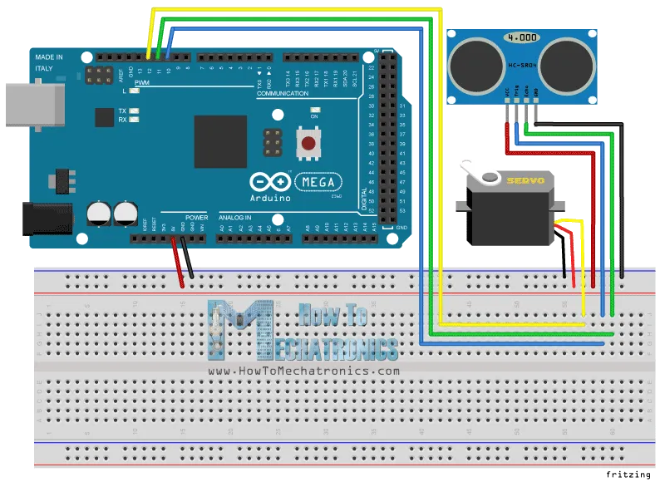

**5. TEST**

We have tested several times so that we can overcome our problems and improve our solution to develop our prototype. We have got error while running the processing code first we have no idea about that app so it took time to understand and run the code.

We have also found errors in uploading the code to the Arduino that it is showing compile error. we didn't include the library files to code.so, we installed the library file named <servo.h> in the Arduino software. Then code complied successfully and done uploading.

At last, we have successfully completed our project and we have got the output what we have expected from the idea we have developed.

By innovation in our project, we can save lives of humans and animals from accidents and this can be used near the gates so that watchman can open gate when he gets signal that there is a vehicle at the door.

**6.REFERENCES**

* [*http://www.circuitbasics.com/how-to-set-up-the-dht11-humidity-sensor-on-an-arduino/*](http://www.circuitbasics.com/how-to-set-up-the-dht11-humidity-sensor-on-an-arduino/)
* [*https://playground.arduino.cc/Main/DHT11Lib*](https://playground.arduino.cc/Main/DHT11Lib)
* [*https://www.interaction-design.org/literature/article/stage-5-in-the-design-thinking-process-test#:~:text=Testing%2C%20in%20Design%20Thinking%2C%20involves%20generating%20user%20feedback,as%20gaining%20a%20deeper%20understanding%20of%20your%20users*](https://www.interaction-design.org/literature/article/stage-5-in-the-design-thinking-process-test#:~:text=Testing%2C%20in%20Design%20Thinking%2C%20involves%20generating%20user%20feedback,as%20gaining%20a%20deeper%20understanding%20of%20your%20users)*.*
* [*https://www.interaction-design.org/literature/article/stage-4-in-the-design-thinking-process-prototype#:~:text=Prototypes%20are%20often%20used%20in%20the%20final%2C%20testing,or%20not%20the%20implemented%20solutions%20have%20been%20successful*](https://www.interaction-design.org/literature/article/stage-4-in-the-design-thinking-process-prototype#:~:text=Prototypes%20are%20often%20used%20in%20the%20final%2C%20testing,or%20not%20the%20implemented%20solutions%20have%20been%20successful)*.*